QUERIES IN SQL

1 #Retrieve all successful bookings:
create view Successful_Bookings As
select * from bookings
where booking_status = "Success";
select * from Successful_Bookings;
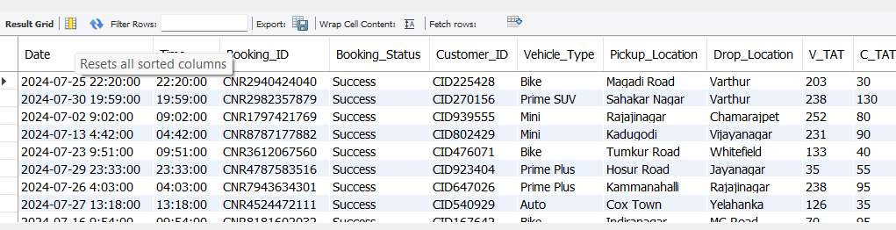

2 #average ride distance for each vehicle type:
select * from ride_distance_for_each_vehicle;
create view ride_distance_for_each_vehicle As
select Vehicle_type, avg(Ride_Distance)
as Avg_distance from bookings
group by Vehicle_type;
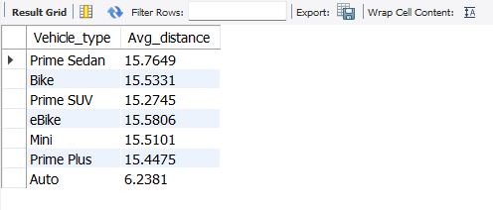

3 #Get the total number of canceled rides by customers:
create view canceled_rides_by_customers as
select count(*) from bookings
where Booking_Status = 'Canceled by Customer';
select * from cancelled_rides_by_customers;
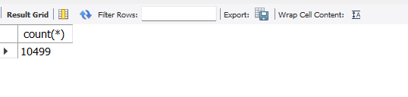

#4. List the top 5 customers who booked the highest number of rides:
Select * from booked_the_highest_number_of_rides
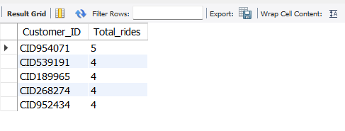

#5. The number of rides canceled by drivers due to personal and car-related issues:
create view cancelled_by_drivers As
select count(*) from bookings
where Canceled_Rides_By_Driver = "Personal & car related issue";
select * from cancelled_by_drivers;
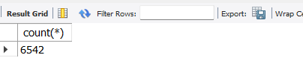

#6. Find the maximum and minimum driver ratings for Prime Sedan bookings:
create view max_min_driver_ratings as
select max(Driver_Ratings) as max_ratings,
min(Driver_Ratings) as min_ratings
from bookings where Vehicle_Type = "Prime Sedan";
select * from max_min_driver_ratings;
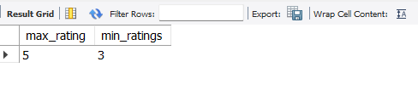
#7. All rides where payment was made using UPI
create view Payment_Method_UPI as
Select * from Bookings where Payment_Method = "UPI";
Select * from Payment_Method_UPI
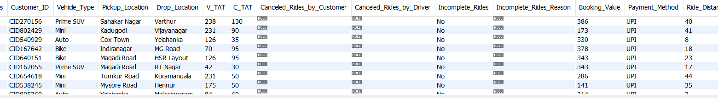

#8. Find the average customer rating per vehicle type:
Create view Avg_Customer_Ratings As
select Vehicle_Type, avg(Customer_Rating) as avg_customer_ratings
from bookings
group by Vehicle_Type;
select * from Avg_Customer_Ratings;
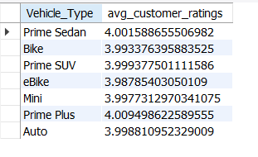
#9. The total booking value of rides completed successfully
create view total_booking_value_R_C as
select sum(Booking_Value) as total_booking_value
from bookings
where Booking_Status = "Success";
select * from total_booking_value_R_C;
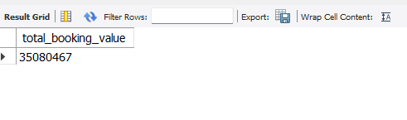
#10. List all incomplete rides along with the reason
create view Incomplete_rides_with_reasons AS
select Booking_ID, Incomplete_Rides_Reason
from bookings
where Incomplete_Rides = "Yes";
Select * from Incomplete_rides_with_reasons;
